A1135-Eur-Czech Republic-Moravia-Dolní Věstonice-Figurine-Mammoth-Ivory-26,000 BP

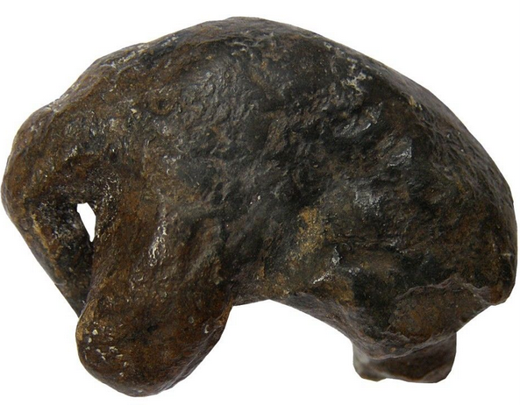

Fig. 1. Czech Republic-Moravia-Dolní Věstonice-Figurine-Mammoth-Ivory-26,000 BP

**Formal Label:** Czech Republic-Moravia-Dolní Věstonice-Figurine-Mammoth-Ivory-26,000 BP

**Display Description:** This ivory carving of a mammoth suggests that the artist was trying to capture the position of this animal in the midst of a howling snowstorm when all it could do was to protect its head from the pelting snow. This sculpture comes fromone of the most famous Moravian sites, Dolní Věstonice, situated on the hill of Pollau at 549 m asl (1,801 ft). Since remains of molluscs, spruce and pollen from the site suggest that it was occupied during a cold climate with a tundra environment this could well explain the pose of the mammoth sculpted here. This site was excavated in the 1920s and again in 1947-52 (Klima 1963), and it has been a source of artifacts of the Gravettian period (27,000-20,000 BP).

**Accession Number: A1135**

**LC Classification:** GN772.22.C95

**Date or Time Horizon:** 26,000 BP C14.

**Accession Number: A1135**

**LC Classification:** GN772.22.C95

**Date or Time Horizon:** 26,000 BP C14.

**Geographical Area:** Czech Republic, Dolní Věstonice, Moravia, at the base of the hill of Pollau.

**Map, GPS Coodinates**: 48.88822 16.64369, 40° 26' 46" N 79° 58' 56" W

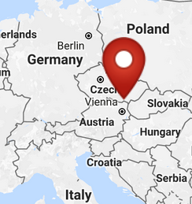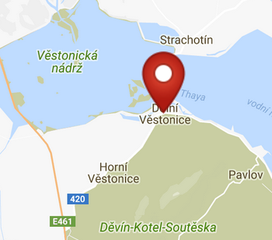

Fig. 2-3. Maps of the location of Dolní Věstonice from <http://latitude.to/img/latitude-logo.svg>.

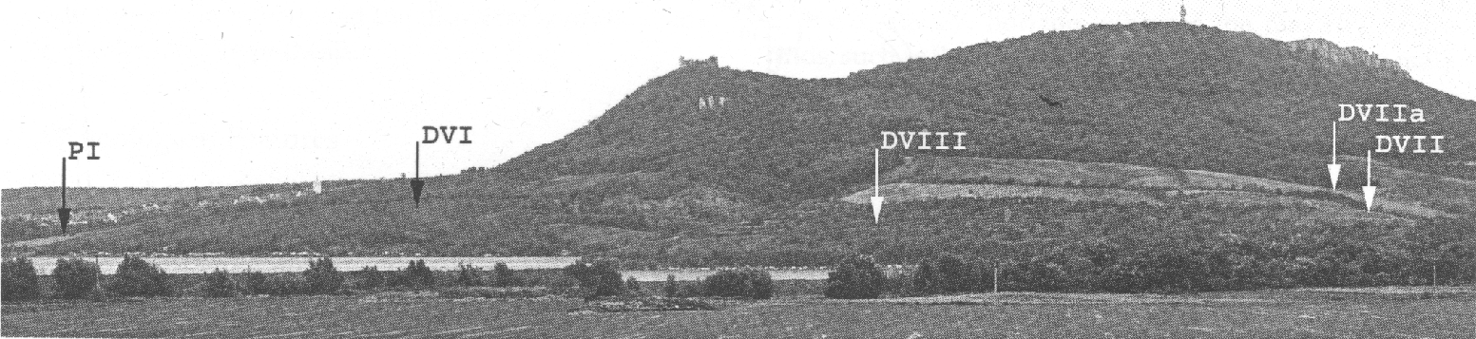

Fig. 4. Pavloski Hills showing profile of where sites are located. Photo by M. Novak. (Trinkaus and Svoboda 2005: Fig. 3.2)

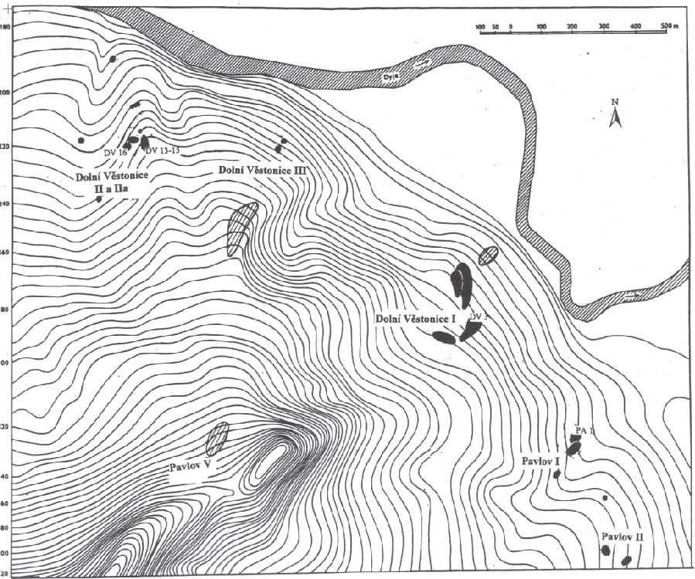

Fig. 5. Map of the location of Dolní Věstonice where sites are located and where burials marked DV are located and where Pavlov sites and burials marked PA are located (Trinkaus and Svoboda 2005: Fig. 3.1).

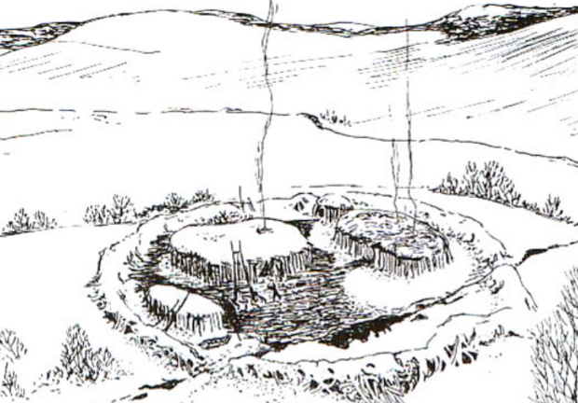

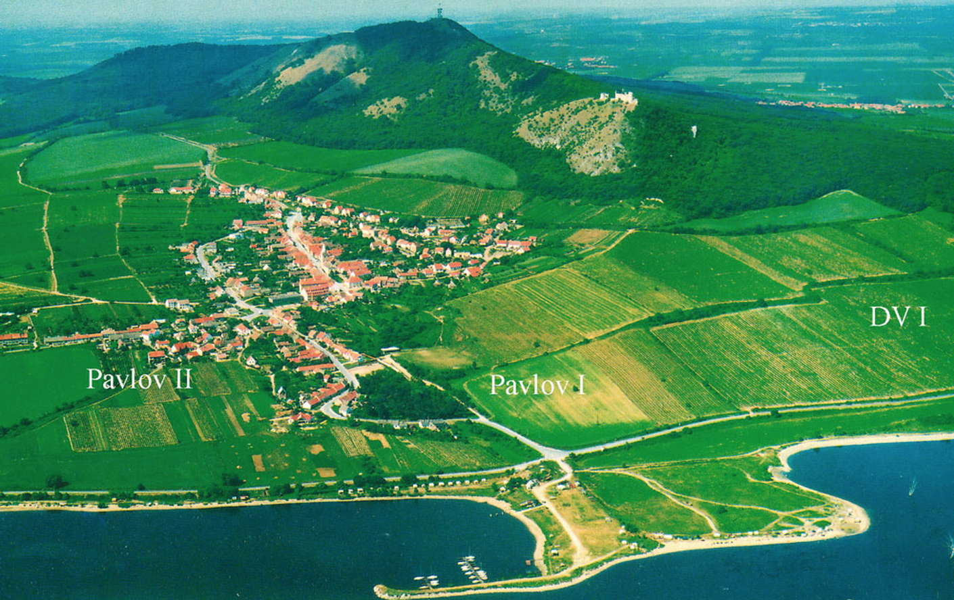

Fig. 6. Artist’s reconstruction of huts within enclosure wall at Dolní Věstonice, Moravia, Czech Republic, 29,000 BP, after <http://humanpast.net/images/dolni.JPG>.

Fig. 7. Aerial view of Dolní Věstonice, Moravia, Czech Republic, 2004, after Svoboda (2007)

**Cultural Affiliation:** Gravettian Period (27,000-20,000 BP)

**Medium:** mammoth ivory

**Dimensions:   
Weight: original, unknown.**

**Provenance: Moravian Museum in Brno, acc. No. 30020**

**Condition:** museum replica in resin.

**Discussion:** Dolní Věstonice, Moravia in the Czech Republic, is on the hill of Pollau 549 m (1,801 ft), dating to approximately 26,000 BP. The site has been a source of artifacts of the Gravettian period (27,000-20,000 BP).

**References:**

Klima, B. 1963. *Dolni Vestonice. Erforschung eine Lagenplatzes der Mammutjager an der Jahren 1947-52* Monum. Archaeol., XI.

Trinkaus, Erik and Jiri Svoboda (Eds.) 2005.*Early Modern Human Evolution in Central Europe: The People of Dolní Vestonice and Pavlov* (Human Evolution Series). New York: Oxford University Press.

Verpoorte, A**.** 2000. *Camps, boundaries and art*, https://openaccess.leidenuniv.nl/bitstream/handle/1887/13512/ASLU08_09.pdf